Clinical Ground-Truth Check of High-CATE Latent-State Results
PhysioNet 2012 and MIMIC CSV summaries

Executive summary
The two CSV summary files were reviewed and mean_cate was interpreted as the model-estimated absolute mortality-rate increase associated with setting a binary latent/exposure tag to 1. This interpretation is useful for prioritizing and comparing signals, but it should not be treated as equivalent to a randomized treatment effect because most variables represent disease states or organ-dysfunction proxies rather than therapeutic interventions.
The strongest clinically supported positive signals are hepatic dysfunction, renal dysfunction, global severity, metabolic derangement, and coagulation dysfunction. These findings are broadly consistent with ICU literature showing that organ dysfunction and higher SOFA-like severity are associated with increased mortality [1,2]. Hyperbilirubinemia/liver dysfunction and acute kidney injury have especially strong supporting evidence [3-7].
Two findings require particular caution: the very low or negative shock effects and the negative PhysioNet heme/coag effect. Clinically, septic or circulatory shock is a high-mortality syndrome; Sepsis-3 defines septic shock using vasopressor-requiring hypotension and lactate elevation, with hospital mortality exceeding 40% [1]. Accordingly, PhysioNet Shock = -0.6 pp and MIMIC Shock = +2.2 pp are more likely to reflect proxy construction, confounding, treatment selection, or coding limitations than true protective or negligible mortality effects.

Important sanity check before clinical interpretation
Across both CSVs, treated_outcome_positive_rate is often lower than the overall outcome_rate even when mean_cate is strongly positive. For example, MIMIC HepaticDysfunction has outcome_rate = 12.1%, treated_outcome_positive_rate = 3.1%, and mean_cate = +15.5 pp; PhysioNet RenalFail has outcome_rate = 14.2%, treated_outcome_positive_rate = 6.2%, and mean_cate = +12.5 pp. This pattern does not, by itself, invalidate the CausalForest estimate, but it indicates that the treated outcome column should not be interpreted as raw mortality risk without confirming outcome coding, sample restrictions, and whether the positive outcome denotes mortality or survival. It also increases the need for calibration and sensitivity checks.

1. CSV summary readout

PhysioNet 2012
Rank | Latent/exposure | n | Outcome rate | Treatment rate | Treated outcome positive | Mean CATE
1 | RenalFail | 7,993 | 14.2% | 23.2% | 6.2% | +12.5 pp
2 | HepFail | 7,993 | 14.2% | 17.2% | 4.1% | +10.1 pp
3 | Severity | 7,993 | 14.2% | 46.7% | 9.4% | +9.2 pp
4 | Metab | 7,993 | 14.2% | 52.6% | 10.7% | +8.7 pp
5 | Inflam | 7,993 | 14.2% | 65.6% | 11.9% | +5.7 pp
6 | NeuroFail | 7,993 | 14.2% | 64.7% | 11.0% | +4.5 pp
7 | RespFail | 7,993 | 14.2% | 65.3% | 11.0% | +4.4 pp
8 | Shock | 7,993 | 14.2% | 63.4% | 10.6% | -0.6 pp
9 | HemeFail | 7,993 | 14.2% | 64.3% | 9.5% | -1.8 pp

MIMIC
Rank | Latent/exposure | n | Outcome rate | Treatment rate | Treated outcome positive | Mean CATE
1 | HepaticDysfunction | 26,845 | 12.1% | 10.0% | 3.1% | +15.5 pp
2 | Severity | 26,845 | 12.1% | 63.2% | 10.4% | +10.0 pp
3 | Inflammation | 26,845 | 12.1% | 76.8% | 11.4% | +6.8 pp
4 | RenalDysfunction | 26,845 | 12.1% | 62.5% | 10.2% | +6.6 pp
5 | CoagDysfunction | 26,845 | 12.1% | 42.2% | 7.6% | +6.2 pp
6 | MetabolicDerangement | 26,845 | 12.1% | 63.2% | 10.4% | +6.1 pp
7 | RespFail | 26,845 | 12.1% | 67.3% | 10.6% | +5.0 pp
8 | NeuroDysfunction | 26,845 | 12.1% | 56.2% | 9.5% | +4.5 pp
9 | Shock | 26,845 | 12.1% | 78.0% | 11.3% | +2.2 pp

2. Visual ranking
The charts below show mean_cate as absolute mortality percentage-points. Positive values mean the model estimates higher mortality if the latent/exposure tag is set to 1; negative values mean the model estimates lower mortality.
PhysioNet
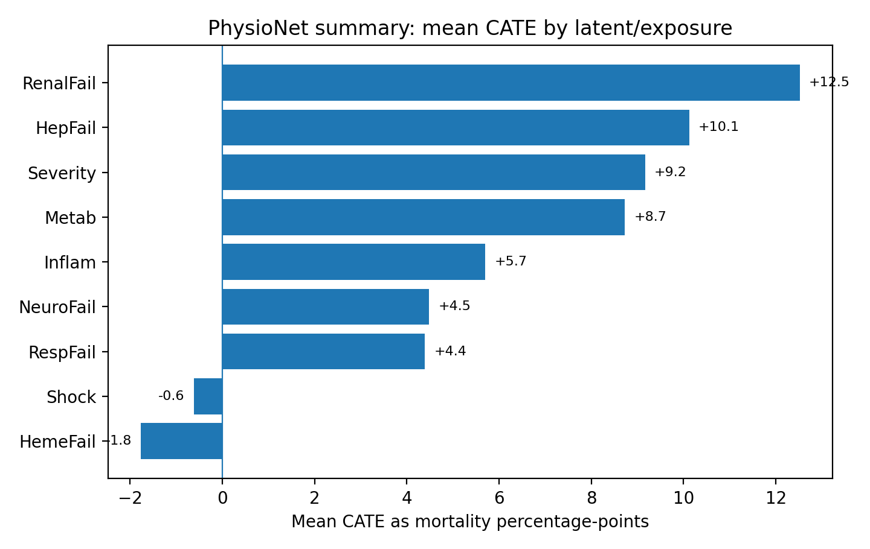
MIMIC
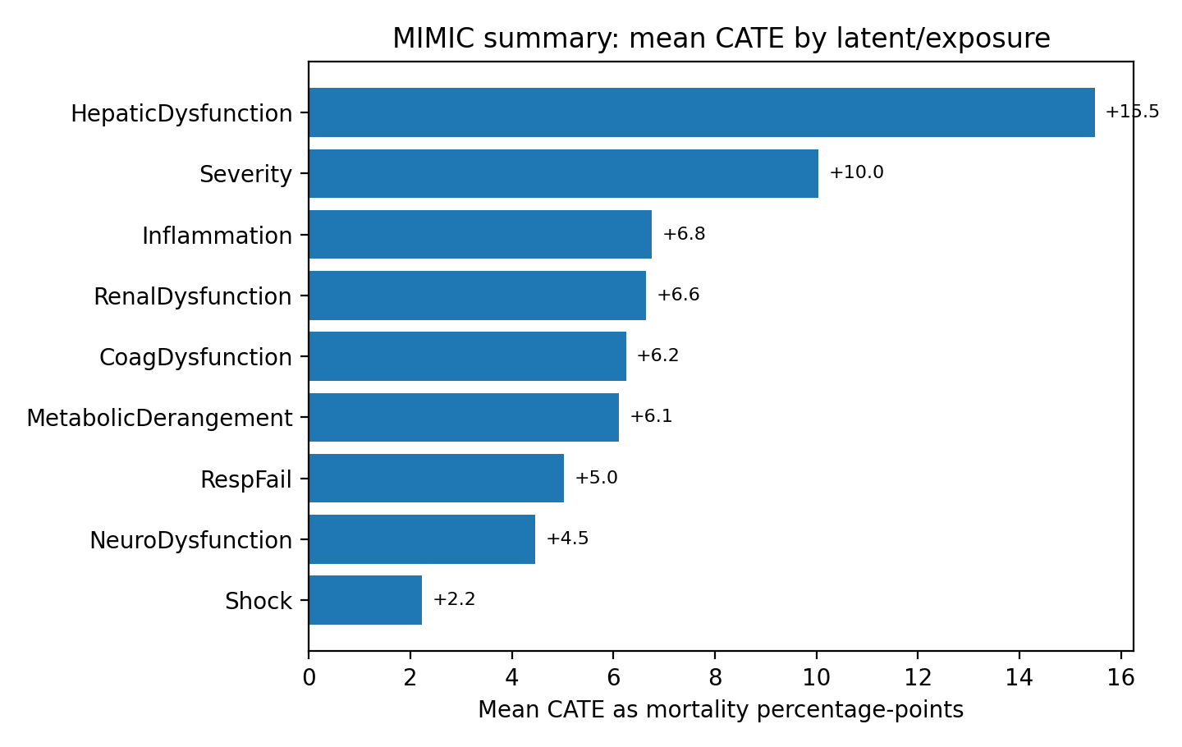

3. Evidence hierarchy and source strategy
The evidence review prioritized peer-reviewed studies, consensus definitions, and clinical guidelines. Clinician-community and educational sources, including LITFL and EMCrit, were used only as practice-context checks rather than primary evidence; their role is mainly supportive when their interpretation aligns with peer-reviewed literature [12,13].
- Tier 1: Consensus definitions/guidelines: Sepsis-3, SOFA, KDIGO, Berlin ARDS.
- Tier 2: ICU cohort studies and propensity/adjusted analyses for AKI, bilirubin/liver dysfunction, lactate/acidosis, and thrombocytopenia.
- Tier 3: Medical forum/educational sources used only to check whether the interpretation matches bedside critical-care reasoning.

4. Medical evidence validation by high-CATE result
Latent/exposure | CSV signal | Ground-truth clinical interpretation | Evidence verdict | Main caveat
Hepatic dysfunction / HepFail | MIMIC +15.5 pp; PhysioNet +10.1 pp | Strongly plausible direction. Bilirubin/liver dysfunction is part of SOFA-like organ failure; ICU studies report higher mortality with hyperbilirubinemia, and cholestatic liver dysfunction is associated with markedly increased mortality [5-7]. | Supported, but not proven as an isolated causal effect. | Magnitude may reflect multi-organ failure, shock, sepsis, or parenteral nutrition/drug effects. Some literature warns bilirubin can be a severity marker more than an independent cause.
Renal dysfunction / RenalFail | MIMIC +6.6 pp; PhysioNet +12.5 pp | Clinically plausible. AKI is common in ICU patients and increasing AKI severity is associated with increased mortality [3]. A 2024 multicenter sepsis-AKI analysis found overall AKI attributable mortality of 6.6 pp, with stage 3 AKI at 16.8 pp [4]. | Supported; PhysioNet magnitude is plausible only if tag captures severe AKI. | If the label captures chronic kidney disease or mild creatinine changes, the +12.5 pp PhysioNet effect is probably high.
Global severity | MIMIC +10.0 pp; PhysioNet +9.2 pp | Strongly plausible as a risk marker. SOFA assesses neurologic, blood/coagulation, liver, kidney, and hemodynamic function; higher SOFA corresponds to higher likely mortality [2]. Sepsis-3 uses SOFA increase >=2 as organ dysfunction associated with >10% in-hospital mortality [1]. | Supported as prognostic severity, not as a manipulable treatment effect. | Do not say 'severity treatment causes death.' Severity is a composite, outcome-proximal latent state and may absorb effects of shock/organ failures.
Metabolic derangement / Metab | MIMIC +6.1 pp; PhysioNet +8.7 pp | Plausible. Lactate, acidosis, electrolyte abnormalities, and glucose extremes are downstream signals of shock, renal failure, respiratory failure, sepsis, and poor perfusion. ICU lactate studies associate hyperlactatemia/persistent lactate elevation with bad outcomes and mortality [9]. | Supported; magnitude plausible. | Metabolic derangement is often a mediator, not a root cause. Estimating its isolated effect can block upstream causal pathways.
Inflammation / sepsis-like burden | MIMIC +6.8 pp; PhysioNet +5.7 pp | Moderately plausible. Sepsis is organ dysfunction caused by dysregulated host response to infection; septic shock is a higher-mortality subset [1]. Inflammation-only tags based on fever/WBC/lactate are less specific than confirmed sepsis. | Supported direction; effect should be lower than organ failure when infection confirmation is missing. | False positives include post-op inflammation, trauma, pancreatitis, and sterile shock. This likely explains why inflammation is below hepatic/renal/severity.
Coagulation / heme dysfunction | MIMIC +6.2 pp; PhysioNet HemeFail -1.8 pp | MIMIC positive direction is supported. Thrombocytopenia at ICU admission was associated with 90-day mortality in PLOT-ICU, and thrombocytopenia occurred frequently in critically ill patients [10]. | MIMIC supported; PhysioNet negative is likely inaccurate. | PhysioNet HemeFail may combine weak proxies (HCT/WBC/platelets) and suffer from missingness or over-adjustment. A negative mortality effect contradicts the clinical literature.
Respiratory failure / RespFail | MIMIC +5.0 pp; PhysioNet +4.4 pp | Positive direction is supported. Berlin ARDS severity categories showed increasing mortality from mild to moderate to severe ARDS [8]. Respiratory failure also contributes to acidosis and global severity. | Supported but probably conservative. | Labels may include post-operative ventilation or oxygen support, which dilutes true hypoxemic respiratory failure.
Neurologic dysfunction / NeuroFail | MIMIC +4.5 pp; PhysioNet +4.5 pp | Positive direction is plausible. GCS is the neurologic SOFA component and has been reported as a dominant component of SOFA's association with 30-day mortality in mixed ICU patients [11]. | Supported direction; magnitude uncertain. | Sedation, intubation, and missing neurologic assessments can misclassify true brain dysfunction.
Shock | MIMIC +2.2 pp; PhysioNet -0.6 pp | Clinical literature strongly contradicts the low/negative CATE. Sepsis-3 septic shock criteria identify a subgroup with hospital mortality in excess of 40% [1]. True shock should be among the highest-risk states, not near zero. | Likely inaccurate or heavily mediated/over-adjusted in these results. | PhysioNet lacks vasopressors; shock tags may be broad hypotension/tachycardia proxies. Adjusting for severity, renal failure, metabolic derangement, or ventilation can remove the mortality pathway from shock.

5. Relative relationships implied by the two CSVs
These ratios compare model-estimated mean CATE values within each dataset. They are useful as hypotheses, not proofs.
Comparison | MIMIC ratio | PhysioNet ratio | Interpretation | Clinical confidence
Hepatic vs inflammation | 2.29x | 1.78x | Consistent: hepatic dysfunction is ~2x inflammation. Clinically plausible because hepatic dysfunction often reflects established organ failure rather than nonspecific inflammatory signal. | High
Severity vs inflammation | 1.49x | 1.61x | Consistent: severity is ~1.5-1.6x inflammation. This fits SOFA-like multi-organ severity as more outcome-proximal than fever/WBC/inflammation. | High
Renal vs inflammation | 0.98x | 2.20x | Mixed: MIMIC renal is about equal to inflammation; PhysioNet renal is >2x. Difference likely reflects label severity, baseline creatinine handling, and available urine-output/renal variables. | Medium
Metabolic vs respiratory | 1.22x | 1.99x | Metabolic derangement is higher than respiratory failure in both datasets, especially PhysioNet. This is plausible when metabolic labels capture lactate/acidosis as global shock/sepsis mediators. | Medium
Shock vs severity | 0.22x | -0.07x | Contradictory: model shock is far below severity and even negative in PhysioNet. True shock should be high risk; this points to proxy/model problems. | Low for shock

6. Dataset-specific interpretation

PhysioNet 2012
- Top positive CATEs are RenalFail (+12.5 pp), HepFail (+10.1 pp), Severity (+9.2 pp), and Metab (+8.7 pp). This ordering is clinically plausible if the tags identify substantial organ dysfunction rather than mild abnormalities.
- Inflam (+5.7 pp), NeuroFail (+4.5 pp), and RespFail (+4.4 pp) are plausible but lower-confidence because PhysioNet has no diagnoses, antibiotics, cultures, vasopressors, sedation, or procedures. This makes confirmed sepsis, true shock, and ventilator-related respiratory failure hard to identify.
- Shock (-0.6 pp) and HemeFail (-1.8 pp) are the main red flags. The shock sign contradicts established critical-care evidence, and the heme/coag sign contradicts thrombocytopenia literature. These should be flagged as model/proxy artifacts unless sensitivity analysis proves otherwise.

MIMIC
- Top positive CATEs are HepaticDysfunction (+15.5 pp) and Severity (+10.0 pp), followed by Inflammation, RenalDysfunction, CoagDysfunction, and MetabolicDerangement at about +6 to +7 pp. This is broadly compatible with organ-failure literature.
- HepaticDysfunction as the largest signal is plausible if driven by bilirubin/cholestasis, because bilirubin >=2 mg/dL has been associated with materially higher hospital mortality in ICU cohorts [5]. Still, it may be a marker of shock/sepsis/multiorgan failure more than an isolated liver causal effect.
- Shock (+2.2 pp) is clinically too small for true shock. MIMIC has vasopressors and fluids, but if the model adjusts for downstream severity, renal failure, metabolic derangement, or ventilation, the shock effect can be blocked by mediators.

7. Why a clinically true effect can appear too small, too large, or negative
- Mediator over-adjustment: shock causes renal dysfunction, lactate/acidosis, ventilation, and global severity. Adjusting for these downstream states can make the direct shock CATE look near-zero even when the total effect is large.
- Confounding by indication and treatment response: vasopressors, ventilation, dialysis, antibiotics, and measurement intensity are clinician responses to severity. Including them incorrectly can either inflate or suppress disease-state effects.
- Proxy-label noise: a broad tag such as 'Shock' based on transient hypotension or tachycardia will mix true shock with low-risk perioperative physiology; a hepatic tag based on bilirubin will capture more severe multi-organ illness.
- Selection/collider bias: the PhysioNet challenge excludes ICU stays under 48 hours, which can remove early deaths and rapid recoveries. That can distort shock and respiratory failure estimates.
- Outcome coding ambiguity: the treated_outcome_positive_rate pattern should be checked before any publication-quality claim that mean_cate is a mortality-rate increase.

8. Recommended validation analyses
- Audit outcome coding and verify that outcome_positive really means mortality in both CSV generation pipelines.
- Report mean_cate as an estimated effect of a latent-state proxy, not as the harm of a clinical treatment.
- Estimate total effects and direct effects separately. For shock, run models without downstream mediators such as Severity, Metab, RenalDysfunction, and RespFail in the adjustment set.
- Stage renal dysfunction and hepatic dysfunction. For renal, compare mild AKI vs severe AKI/RRT-compatible labels. For hepatic, distinguish bilirubin-driven liver dysfunction from transaminase-only or albumin-only definitions.
- Rebuild shock labels with dataset-specific rules: in MIMIC include vasopressors + lactate/hypotension; in PhysioNet acknowledge that lack of vasopressors limits true shock identification.
- Run sensitivity analyses using matched/stratified estimates, doubly robust methods, and negative-control tags. Shock and PhysioNet HemeFail should be the first stress tests.
- Present relative relationships as hypotheses. The strongest cross-dataset hypothesis is hepatic dysfunction > inflammation in mortality impact; the strongest counterexample is shock, whose model estimate is inconsistent with ground truth.

Bottom line
The CSVs mostly recover the expected clinical hierarchy that organ dysfunction and global severity increase mortality. Hepatic dysfunction, renal dysfunction, metabolic derangement, and coagulation dysfunction have credible medical support as high-risk states. However, the results should not be treated as fully validated causal mortality increments until outcome coding, mediator adjustment, and proxy-label definitions are audited. The strongest likely inaccuracies are the small/negative shock effect and the negative PhysioNet HemeFail effect.

References
[1] Singer M, Deutschman CS, Seymour CW, et al. The Third International Consensus Definitions for Sepsis and Septic Shock (Sepsis-3). JAMA. 2016. https://jamanetwork.com/journals/jama/fullarticle/2492881
[2] HHS ASPR TRACIE. SOFA Score: What it is and How to Use it in Triage. https://files.asprtracie.hhs.gov/documents/aspr-tracie-sofa-score-fact-sheet.pdf
[3] Hoste EAJ, Bagshaw SM, Bellomo R, et al. Epidemiology of acute kidney injury in critically ill patients: the multinational AKI-EPI study. Intensive Care Medicine. 2015;41:1411-1423. https://doi.org/10.1007/s00134-015-3934-7
[4] Wang D-H, Zhao J-C, Xi X-M, et al. Attributable mortality of acute kidney injury among critically ill patients with sepsis: a multicenter, retrospective cohort study. BMC Nephrology. 2024. https://link.springer.com/article/10.1186/s12882-024-03551-9
[5] Yang Z-X, et al. Serum Total Bilirubin Level Is Associated With Hospital Mortality Rate in Adult Critically Ill Patients. Frontiers in Medicine. 2021. https://www.frontiersin.org/journals/medicine/articles/10.3389/fmed.2021.697027/full
[6] Horvatits T, et al. Circulating bile acids predict outcome in critically ill patients. Annals of Intensive Care. 2017. https://link.springer.com/article/10.1186/s13613-017-0272-7
[7] Pierrakos C, et al. Increased mortality in critically ill patients with mild or moderate hyperbilirubinemia. Journal of Critical Care. 2017. https://www.sciencedirect.com/science/article/abs/pii/S0883944116302994
[8] ARDS Definition Task Force. Acute Respiratory Distress Syndrome: The Berlin Definition. JAMA. 2012. https://jamanetwork.com/journals/jama/article-abstract/1160659
[9] van Beest PA, Brander L, Jansen SPA, et al. Cumulative lactate and hospital mortality in ICU patients. Annals of Intensive Care. 2013. https://link.springer.com/article/10.1186/2110-5820-3-6
[10] Anthon CT, Pène F, Perner A, et al. Thrombocytopenia and platelet transfusions in ICU patients: an international inception cohort study (PLOT-ICU). Intensive Care Medicine. 2023;49:1327-1338. https://doi.org/10.1007/s00134-023-07225-2
[11] Knox DB, Lanspa MJ, Kuttler KG, Brewer SC, Brown SM. Glasgow Coma Scale score dominates the association between admission SOFA score and 30-day mortality in a mixed ICU population. Journal of Critical Care. 2014. https://www.sciencedirect.com/science/article/abs/pii/S088394411400210X
[12] LITFL Critical Care Compendium. APACHE versus SOFA scoring systems; ARDS definitions. Used as clinician-education context, not primary proof. https://litfl.com/apache-versus-sofa-scoring-systems/
[13] EMCrit Internet Book of Critical Care. Shock and sepsis chapters. Used as clinician-community context, not primary proof. https://emcrit.org/ibcc/shock/

Internal project files used
physionet_manager_global_summary.csv: CausalForest latent/exposure summaries for PhysioNet 2012.
mimic_manager_global_summary.csv: CausalForest latent/exposure summaries for MIMIC.

